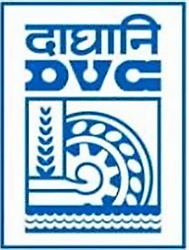
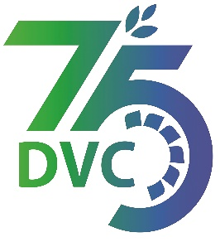
damaooadr GaaTI inagama
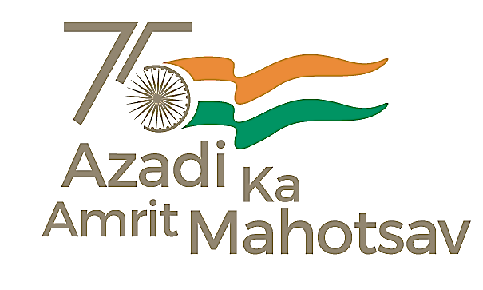
Damodar Valley Corporation
संविदा और सामग्री विभाग
Contracts and Materials Department
डीवीसी टावर्स; तृतीय तल; वीआइपी रोड; कोलकाता-७०००५४ टेली फ़ैक्स न०-०३३-२३५५-२९३६
DVC Towers; 3rd Floor; VIP Road, Kolkata – 700054 Tele fax No.-033 – 2355 –2936.

DATE: 08-03-2024

Abridged version of IFB/NIT for SINGLE STAGE TWO ENVELOPE BIDDING

DVC invites online bids on Single Stage Two Envelope Bidding basis for O&M Package detailed below
---------------------------------------------------------------------------------------------------------------------------------------

Tender ID | To be Published in GEM Portal
Package Name | Maintenance of BG railway track from MTPS to Raniganj connection, a captive Railway system including waiting bay, loops, sidings, (+) ve MGR, (-) ve MGR, fuel oil siding lying inside plant area of DVC, MTPS and other allied works
*Bidding Document Download Starts from (Tentative Dates) | 25.03.2024 onwards.
*DVC reserves the right to amend the dates.

For the detailed IFB/NIT and bidding documents please visit https://etenders.gov.in/eprocure/app from 25.03.2024 onwards or may contact Sr. General Manager, C&M Department, 3rd Floor, DVC Towers, VIP Road, Kolkata, West Bengal, India, PIN – 700054.

Mobile No. +91 9142193462
Email ID: debabrata.das@dvc.gov.in

Registered office:
DVC Towers
VIP Road, Kolkata
West Bengal, India
PIN – 700054

